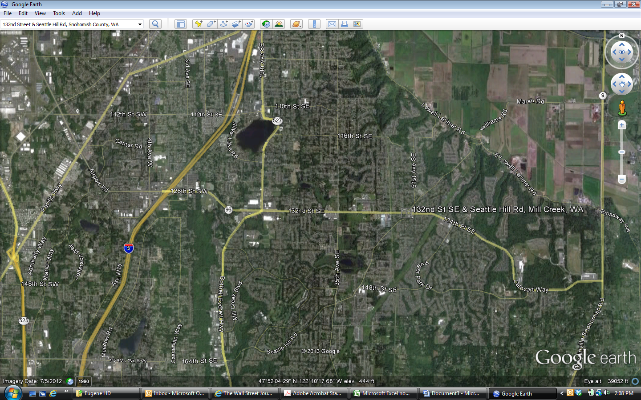

Lowe’s

Fred Meyer

Osborne Square